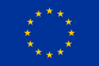
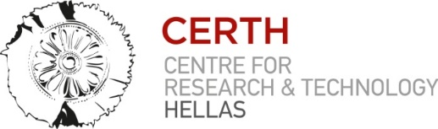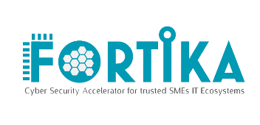

Press Release

Thessaloniki, 25/10/2017

FORTIKA: Protecting SMEs from cyberattacks

Small and medium-sized enterprises (SMEs) have important private information, digital assets and their client’s data just like the Multinational Companies. However, they are typically poorly prepared to defend themselves. It is significant that 60% of targeted attacks in 2015 were aimed at small businesses, while more than 430 million new unique pieces of malware have been discovered, with consequences ranging from minor impact on operational efficiency to detrimental effects on the profitability and/or on the supplier – customer – partner relationship. Clearly, cyber threats comprise a major risk for European businesses and as a rule, their vulnerability increases as their size falls. Given that SMEs are part of a worldwide chain, in which they are suppliers for other companies, their protection from cyberattacks is essential. This is where the opportunity lies and where the FORTIKA concept provides a solution as it aims to minimize the exposure of small and medium sized businesses to cyber security risks and threats. Moreover it aims to help them successfully respond to cyber security incidents, while relieving them from all unnecessary and costly efforts of identifying, acquiring and using the appropriate cyber security solutions.
To fulfil its vision the project adopts a security by design hybrid approach that adequately integrates hardware and software with business needs and behavioral patterns at individual and organizational level. Ultimately, FORTIKA proposes a resilient overall cyber security solution that can be easily tailored and adjusted to the versatile and dynamically changing needs of small businesses. To this end, the project ambitiously aims to make systematic and extensive use of the existing service and product portfolio of security solution providers across Europe.
Finally the introduction of a software-defined smart ecosystem in “FORTIKA Marketplace”, will provide the feature of a light mode solution, which will offer virtualized security services (with minimum downloading requirements). From their perspective, users (i.e. SMEs) may utilize a variety of services and share profiling information with the service providers in return for tailored security services aligned with their actual needs. The FORTIKA marketplace will also function as a single point of access for the profiling information for each SME. FORTIKA Cyber-security framework will be evaluated through five major types of SMEs and will be supported from 2 local SME/ICT clusters and 1 EU alliance.
Note: In June of 2017, project coordinator, Information Technologies Institure, hosted the kick-off meeting of the FORTIKA project in the premises of the Centre for Research and Technology Hellas in Thessaloniki, Greece. The FORTIKA Consortium consists of 16 complementary partners from 9 different European Countries. The project is going to last 3 years.

Contact information
- Dr. Dimitrios Tzovaras – FORTICA coordinator, Director of the Information Technologies Institute/Tel.: 2310 257777 / E-mail: dimitrios.tzovaras@iti.gr
- Amalia Drosou – Extroversion Services/Science communication - CERTH / Τel.: 2310 498214 / E-mail: amelidr@certh.gr

FORTIKA website: http://www.fortika-project.eu/fortika/

